# **Big Countries**

## **Question:**

<https://leetcode.com/problems/big-countries/>

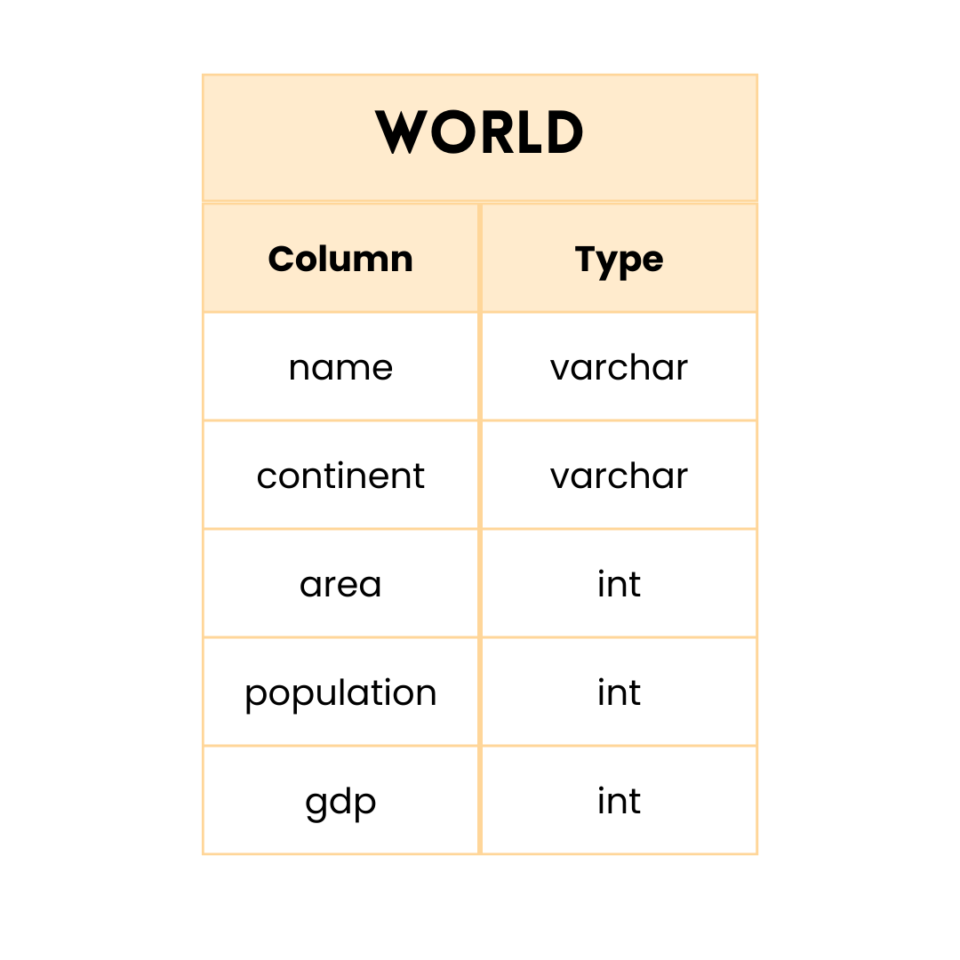

name is the primary key column for this table.

Each row of this table gives information about the name of a country, the continent to which it belongs, its area, the population, and its GDP value.

A country is big if:

* it has an area of at least three million (i.e., 3000000 km2), or
* it has a population of at least twenty-five million (i.e., 25000000).

**Write an SQL query to report the name, population, and area of the big countries.**

**Return the result table in any order.**

## **Query 1**

Using a simple **WHERE** clause and **OR** operator.

SELECT

name,

population,

area

FROM World

WHERE (area>=3000000) OR (population>=25000000)

## **Query 2**

Instead of using **OR**, I tried using **UNION** to join the 2 conditions.

SELECT

name,

population,

area

FROM World

WHERE (area>=3000000)

UNION

SELECT

name,

population,

area

FROM World

WHERE (population>=25000000)

**Fun Fact:** Query 2 is faster than Query 1.

**Another Fun Fact:** This is not always the case. In most comparisons, Query 1 will be faster.

**Explanation for this exceptional case :** <https://leetcode.com/problems/big-countries/discuss/103561/Union-and-OR-and-the-Explanation>